Tugas MBD 4

Sandyatama Fransisna Nugraha - 5025211196

No 1.

-- Select the sid and name of sailor that has a rating greater than the rating average

SELECT sid,sname

FROM Sailors

WHERE rating > (

    SELECT AVG(rating)

    FROM Sailors

);

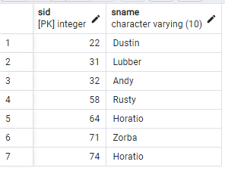

No 2.

-- Select the sid and name of sailor that has the most number of reservations

SELECT s.sid , s.sname

FROM Sailors s

INNER JOIN Reserves r ON s.sid = r.sid

GROUP BY s.sid

ORDER BY COUNT(s.sid) DESC

LIMIT 1

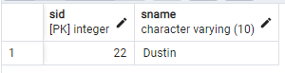

No 3

-- Select the average age of sailors reserving ‘Interlake’ or ‘Marine’ boats

SELECT ROUND(AVG(s.age),2) as Rata_Rata_Umur

FROM Sailors s

INNER JOIN Reserves r ON s.sid = r.sid

INNER JOIN Boats b ON r.bid = b.bid

WHERE b.bname IN ('Interlake', 'Marine')

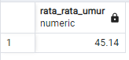

No 4.

-- Select the month and the number of reservations for each month

SELECT EXTRACT(MONTH FROM r.day) AS Month, COUNT(*) AS Number_Reservation

FROM Reserves r

GROUP BY EXTRACT(MONTH FROM r.day)

ORDER BY EXTRACT(MONTH FROM r.day);

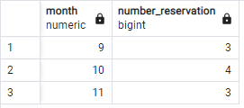

No 5.

-- Select the percentage of red boat reservations of all reservations

SELECT (COUNT(b.color)* 100 / (SELECT COUNT(*) FROM RESERVES)) AS Presentase_Kapal_Merah

FROM reserves r

INNER JOIN boats b ON r.bid = b.bid

WHERE b.color IN (

    SELECT b.color

    FROM Boats b

    WHERE b.color = 'red'

)

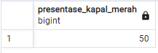

EXERCISE 2

DDL

CREATE DATABASE exercise_provkot

CREATE TABLE Provinsi(

    id_provinsi INTEGER NOT NULL,

    nama_provinsi VARCHAR(50) NOT NULL

);

CREATE TABLE Kota(

    id_kota INTEGER NOT NULL,

    nama_kota VARCHAR(50) NOT NULL,

    id_provinsi INTEGER NOT NULL

);

DML

INSERT INTO Provinsi VALUES

(1,'DKI Jakarta'),

(2,'Jawa Tengah'),

(3,'Papua Barat'),

(4,'Jawa Timur'),

(5,'Jawa Barat');

INSERT INTO Kota VALUES

(1,'Jakarta',1),

(2,'Semarang',2),

(3,'Surabaya',4),

(4,'Malang',4),

(5,'Bandung',5),

(6,'Denpasar',6),

(7,'Makasar',7);

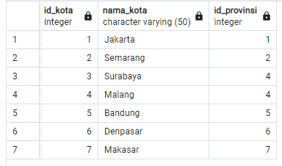

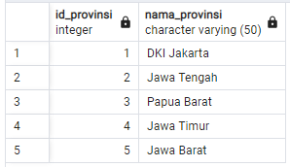

No. 1

-- Select a number of city of “Jawa Timur”

SELECT k.id_kota

FROM Kota k

JOIN Provinsi p ON k.id_provinsi = p.id_provinsi

WHERE p.nama_provinsi = 'Jawa Timur'

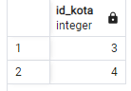

No. 2

-- Select the name of province that has maximum number of city

SELECT p.nama_provinsi

FROM Provinsi p

JOIN Kota k ON p.id_provinsi = k.id_provinsi

WHERE k.id_kota = (

    SELECT MAX(k.id_kota)

    FROM Kota k

)



(NULL)

No. 3

-- Select all province’s name and the number of their cities

SELECT Prov.nama_provinsi, COUNT(Kot.nama_kota)

FROM Provinsi Prov

NATURAL LEFT JOIN Kota Kot

GROUP BY Prov.nama_provinsi

ORDER BY Prov.nama_provinsi;

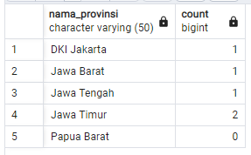

No. 4

-- Select name of provinces and name of cities of those provinces (if the province didn’t have city, the column ‘nama_kota’ will be null)

SELECT p.nama_provinsi, k.nama_kota

FROM Provinsi p

LEFT JOIN Kota k ON p.id_provinsi = k.id_provinsi

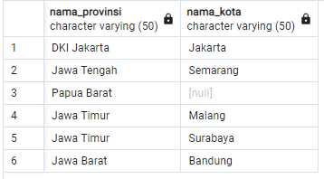

No. 5

-- Select name of provinces that don't have a city

SELECT DISTINCT p.nama_provinsi

FROM Provinsi p

LEFT JOIN Kota k ON p.id_provinsi = k.id_provinsi

WHERE k.id_kota IS NULL

